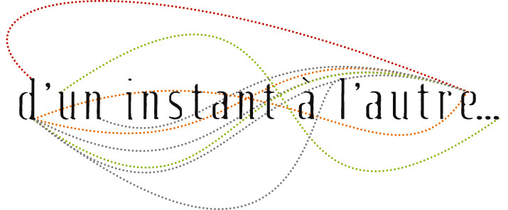
Professional workshop
Ancient Knowledge for Modern Saxophonists
with Hayden Chisholm

Dates
From July 17th to July 20th, 2017
28 hours — 4 days

Schedule
From 9:30 a.m. to 12:30 p.m. and from 2:00 to 6:00 p.m.

Registration
Guillaume Orti
contact@uninstantalautre.com
+33 (0)6 25 11 20 29

Location
In the village of Quincerot (Côte d'Or), France. At the Compagnie D'un instant à l'autre's work studio.

Participants' profiles
Professionnal or semi-professionnal saxophonists, instrumentalist teachers coming from all kinds of musical background (jazz, classical, improvised music, traditional music, “current” music, etc.).

Teaching content
Developed for the last past 12 years during annual master classes in Greece, Hayden Chisholm's teaching brings together a large panel of themes geared towards the saxophon. As a leading expert with his instrument and extensive experience as a composer and improviser, Hayden will address the following topics:
Intonation – Overtone-based ear training, understanding number relationships within intervals, correlation between thythms and intervals, tuning intervals in their natural form, alternate tuning systems, the importance of number in ancient music theory and its uses today, playing with equal temperament.
Microtonal – The quarter tone system for saxophone and its applications, split scales, microtonal ear training, microtonal etudes and more.
Extended Techniques – Multiphonics, tonguing, circular breathing, large interval training, altissimo, extreme dynamics, non-tonal sounds librairies and more.
Developing A Personal Sound – Vocal techniques for sound development, visualizations, blending techniques, mental training, timbral and spectral listening.
Body Work – Breath work, Taiji and Chi gong techniques for optimizing misicianship, stance and balance, achieving somatic relaxation whilst playing, mind-body relationships.
Group Saxophone Work – Study of the saxophone groupe compositions by Hayden, non-notated Works for ensemble, alternate notatinos, study of the Fibonacci row in sound through Hayden’s work Love in Numbers, space awarness techniques for ensemble playing, study and discussion of composition by course participants.
Improvisation – Techniques and tools for solo and group improvisation, memory games, instant composing with complex forms, musical structure in open space.

Hayden Chisholm's biography
New-Zealand saxophonist, composer and teacher who has been living in Germany for more than 20 years, Hayden Chisholm developed some particular concepts on the saxophone. His musical interests cover all kinds of musical situations. He developed a radical new microtonal system ajusted to the saxophone which he termed «split scales». His compositions, from solo to big band, have been recorded by BBC and WDR radios. He has created music for several Rebecca Horn installations and films.

http://haydenchisholm.net

d’un instant à l’autre
Association loi 1901
1, route de Châtillon - 21500 Montbard
N° Siret : 483 308 797 00024 - Code APE : 9001 Z

N° de Licence d'Entrepreneur de Spectacles : 2-1064262
N° d'agrément formation : 26 21 02705 21

